**Cloud Watch EC2 Memory Utilization**

1. Create ec2 role with Cloudwatch and SSM full access

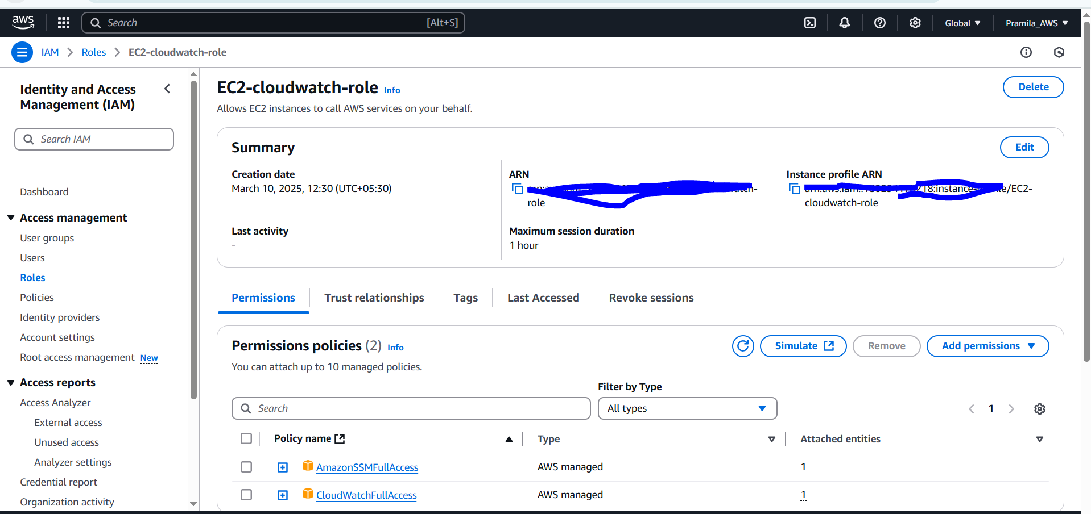

1. Create SSH parameter and store value in it

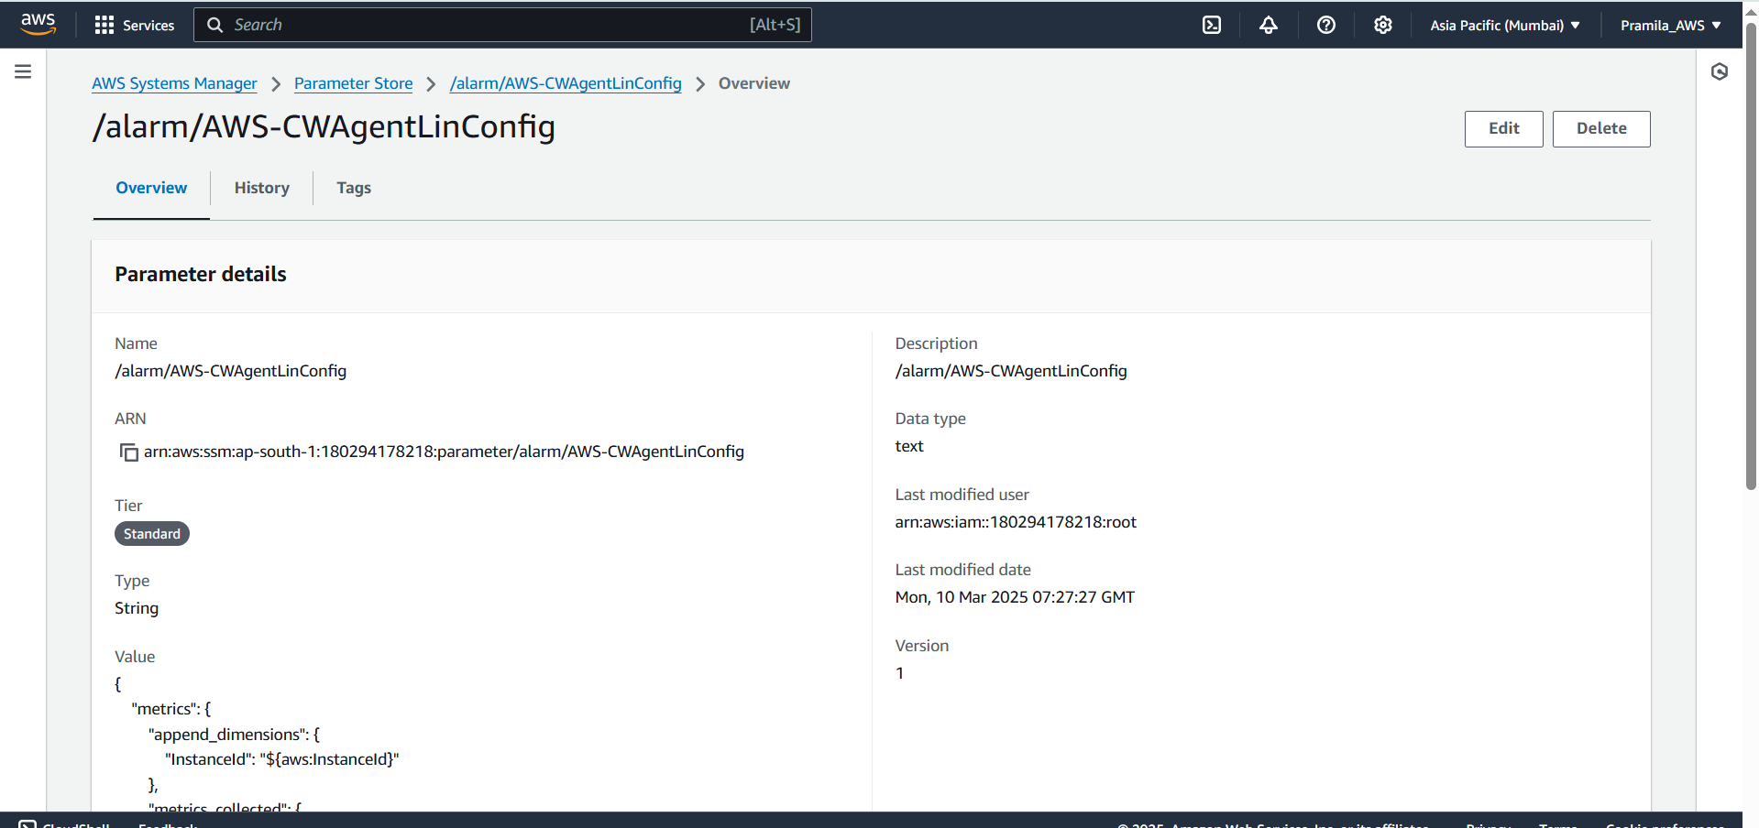

1. Create EC2 instance and add IAM role that we have created with Cloudwatch and SSM full access and then install cloudwatchagent on it using cmd’

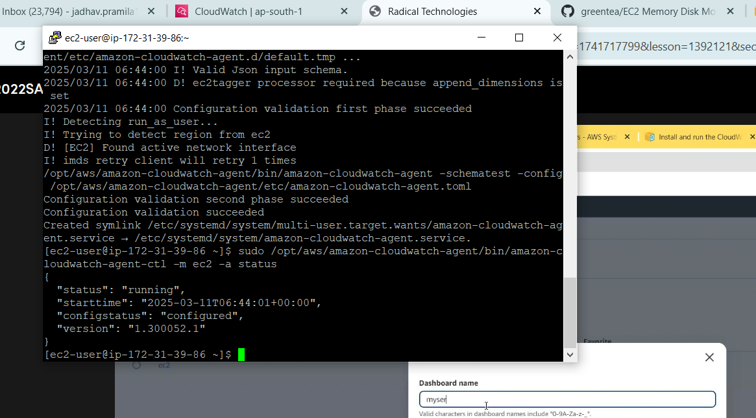

1. Then go to Cloudwatch and create dashboard to monitor ec2 instance CPU,Memory and Disk utilization

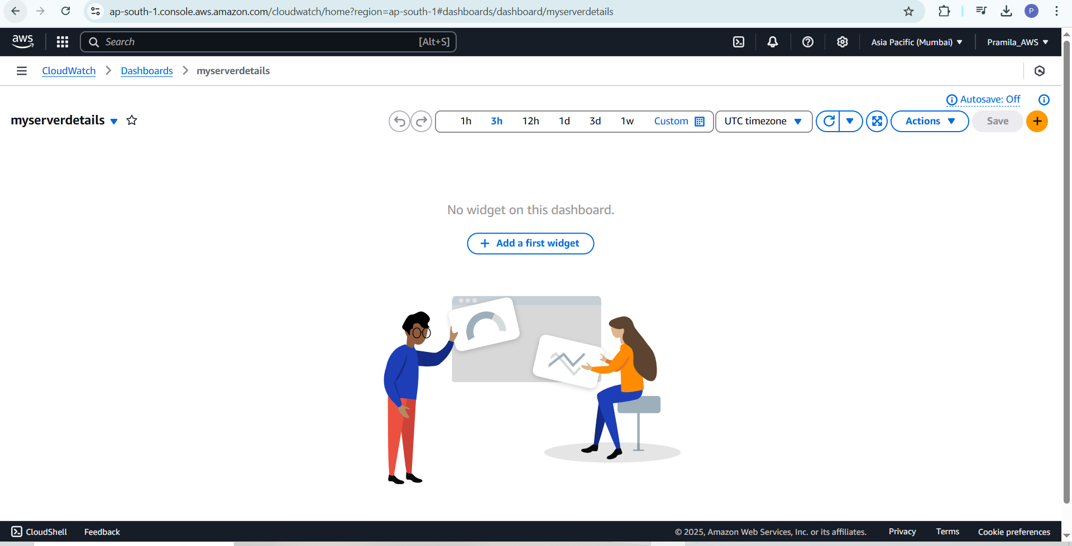

1. Then add widget for CPU utilization

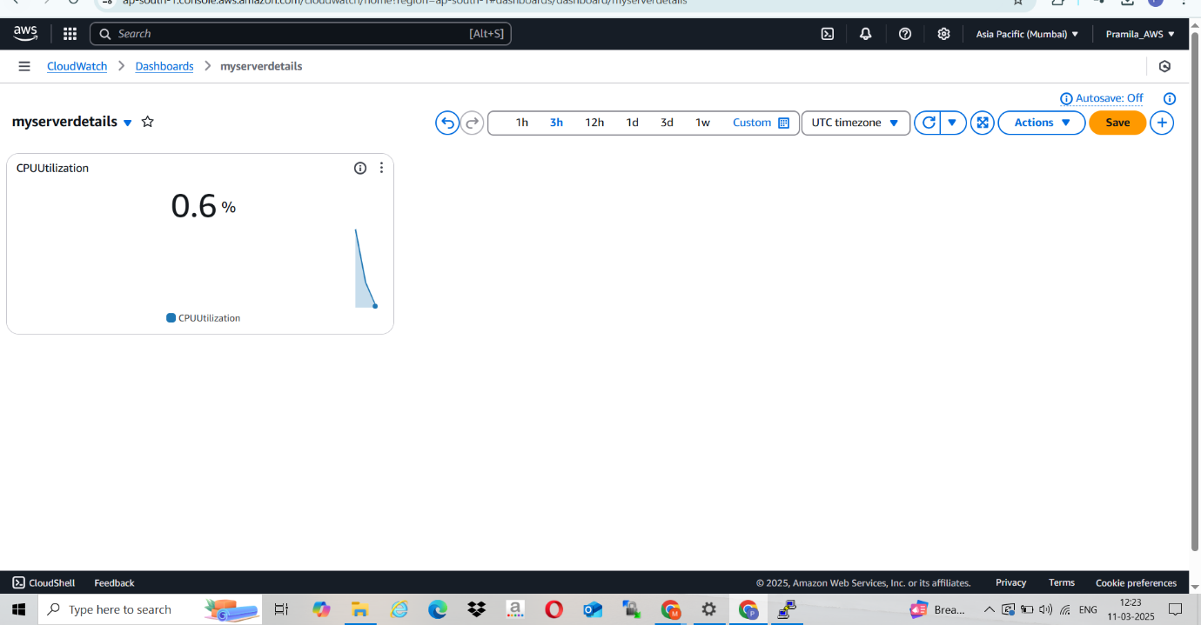

1. Then search CWAgent for Memory Utilization and Disk Utilization

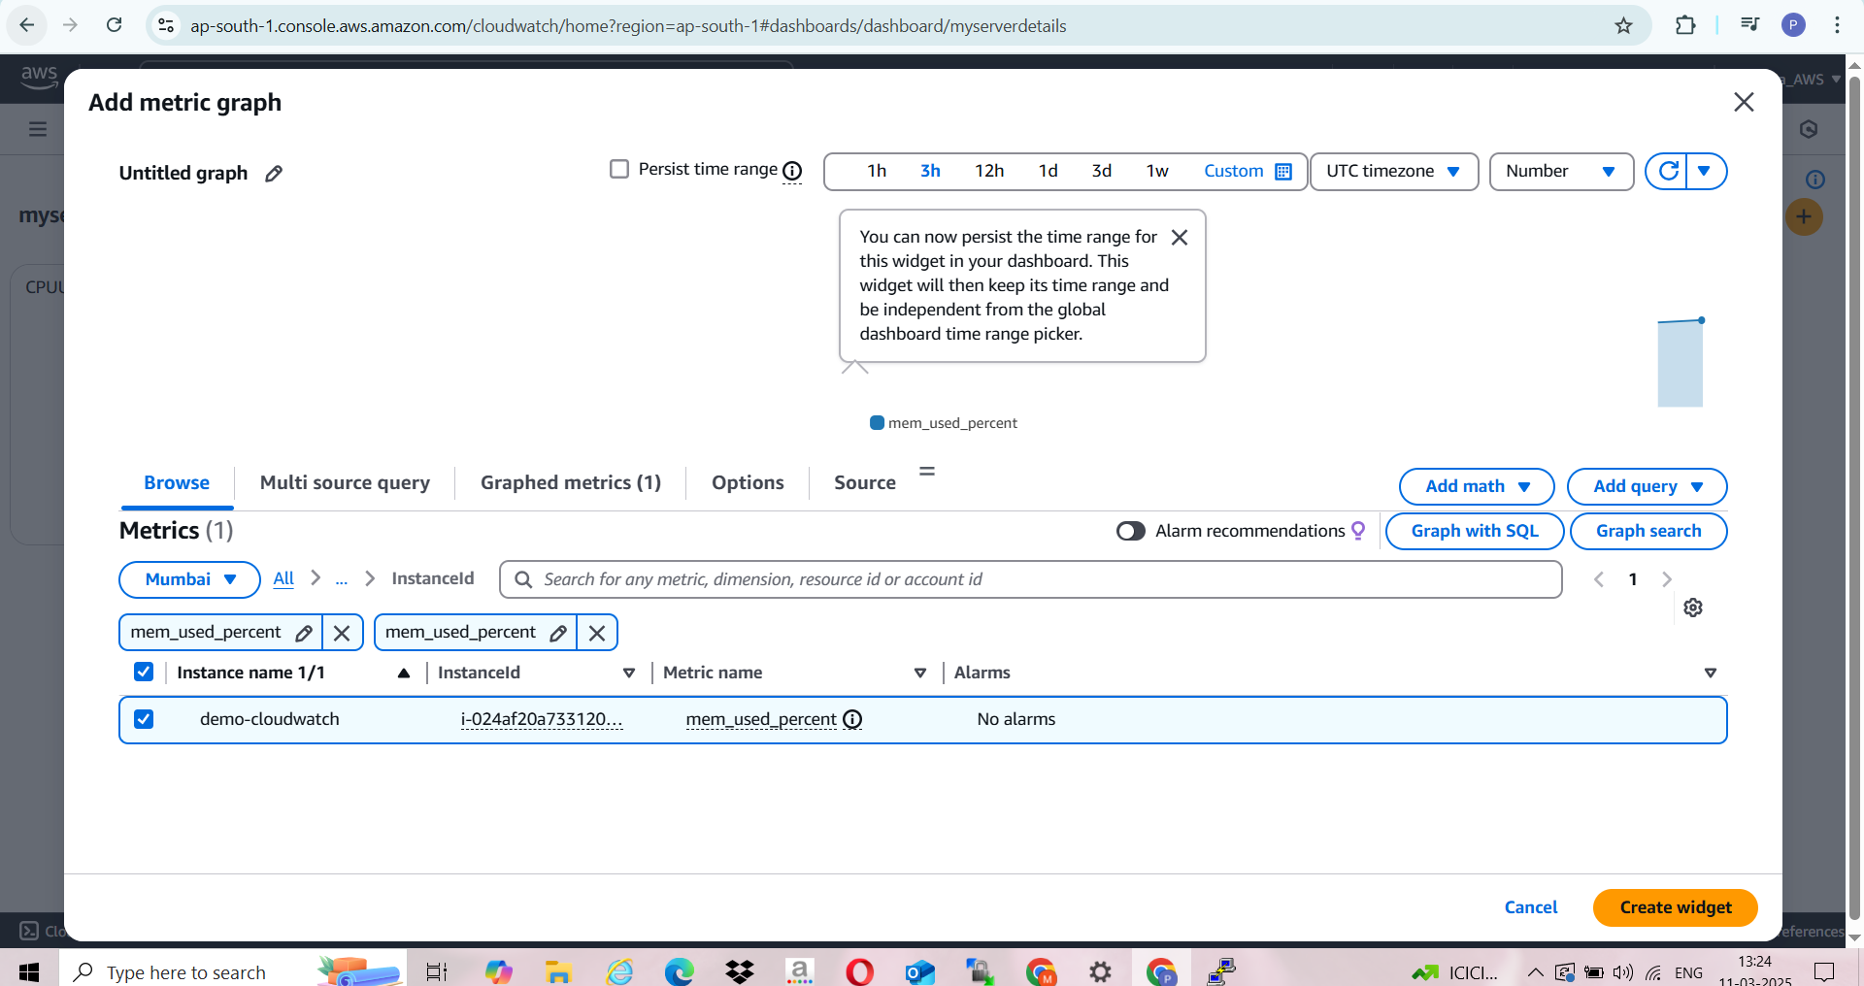

1. Memory Utilization able to see in metrics

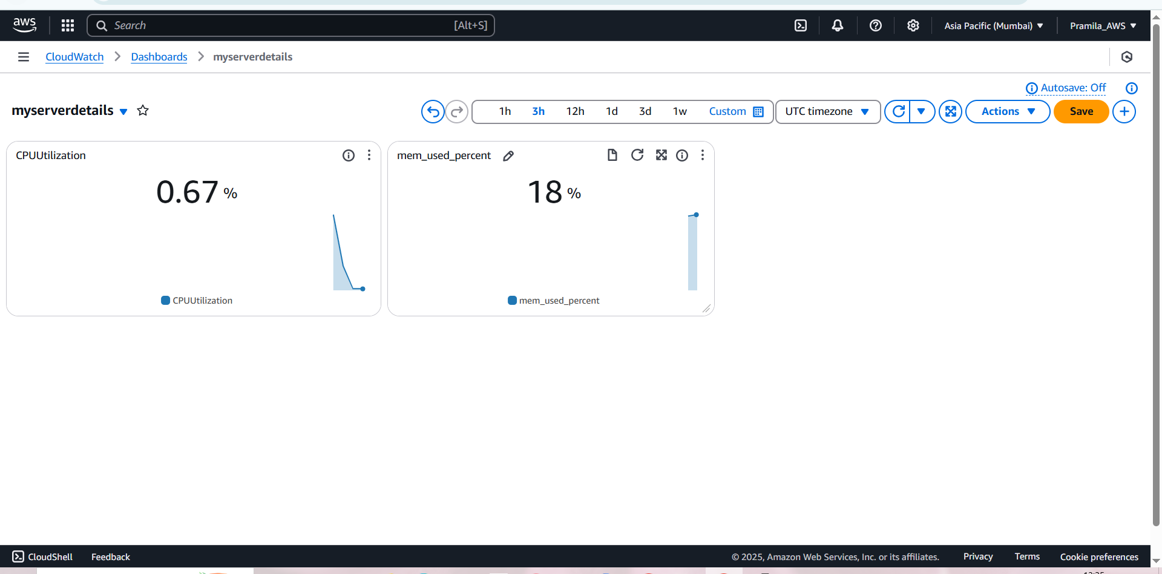

1. Search Disk Utilization and add it

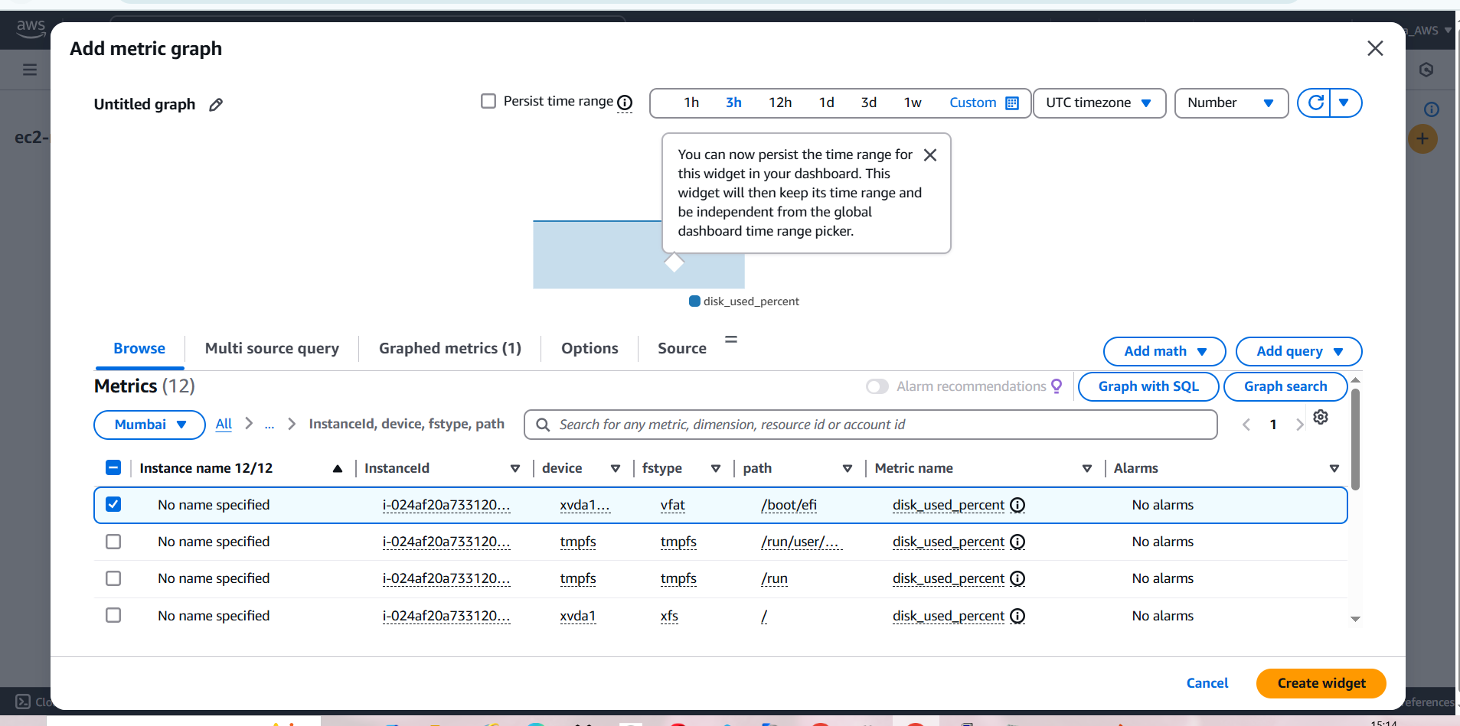

1. All three metrics able to see

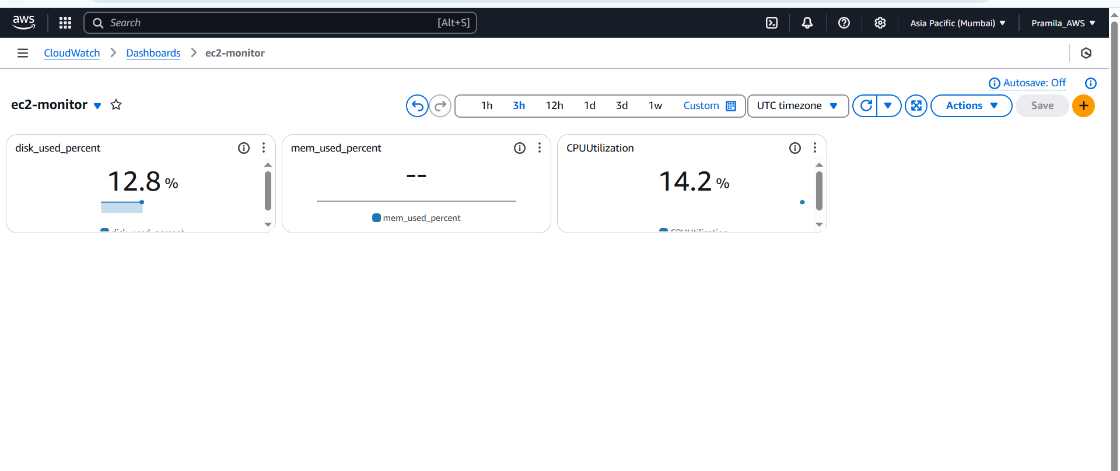

1. Create alarm for Disk Utilization

